**Whole**

**Part**

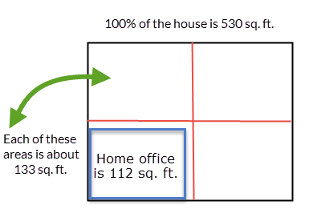

100% of the house is 532.75 sq. ft.

Home office is 120.5 sq. ft.

Your town spends: $16,800

$0 $12,000 $120,000



0% 10% 100%

Your answer: 14%

100%%

3153 total students enrolled

Your answer:  
 52.1%

Number of girls:   
 1644

50%

1577

0%

0

QS1.2

Your answer: $415.39

$0 $400 $800



0% 50% 100%

Percentage your landlord will pay: 55%

Your answer: $1545.94

$0 $1100 $2200



0% 50% 100%

Percentage of checking account: 70%

100%%

15,000 visitors

Your answer:   
 10,200

68% of visitors are from outside New York City

50%

7,500

0%

0

QS1.3

Amount of increase: $100

$0 $150 $1500



0% 10% 100%

Your answer: 6.67%

100%%

768 runners

50%

Amount of   
increase: 73

77

Your answer:   
 9.51%

10%

0%

0

Amount of increase: $17.43

$0 $24 $95.32



0% 25% 100%

Your answer: 18.29%

QS1.4

Amount of decrease: $200

$0 $240 $1200



0% 20% 100%

Your answer: 16.67%

Amount of decrease: $19.68

$0 $24 $120



0% 20% 100%

Your answer: 16.38%

Amount of decrease: $0.50

$0 $0.56 $2.79



0% 20% 100%

Your answer: 17.92%

QS1.5

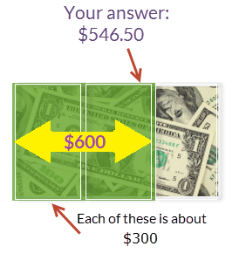

Each of these is   
about $250

Your answer: $496.30

$500

$750

$0

The total park acreage is about 150 acres.

Soccer fields must be about 57.82 acres.

Each of these areas is 75 acres.

Your answer: $26.14

$0

$40



$30

Each of these is   
about $10